Proszę przyjąć model z 3 klasami, systemy tylko typ 1 i 3 tj.

K=414
K =[250, 144, 20]

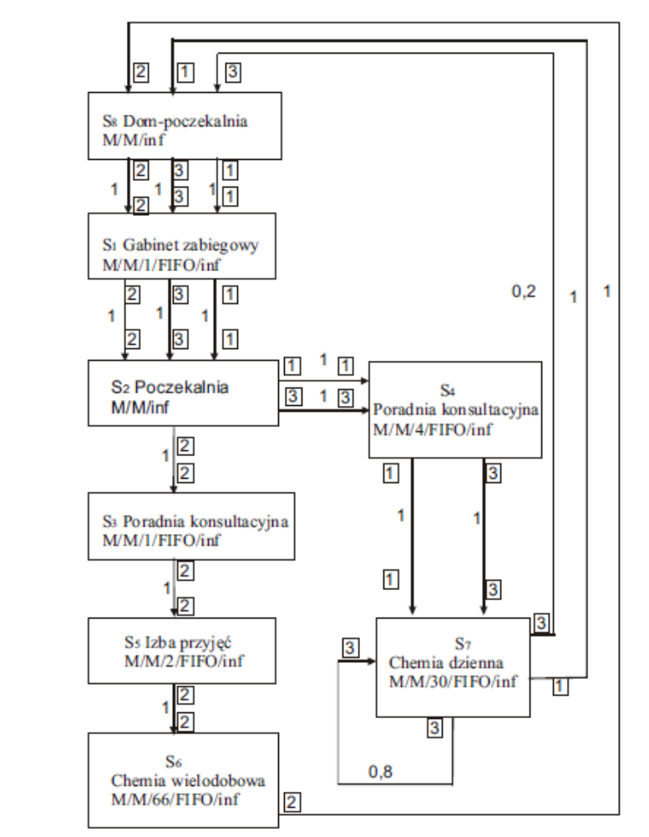

- μ₁ = 67
- μ₂ = 8
- μ₃ = 60
- μ₄ = 8.33
- μ₅ = 12
- μ₆ = 0.218
- μ₇ = 1
- μ₈₁ = 0.092; μ₈₂ = 0.137; μ₈₃ = 0.053
Powinno wyjść w przybliżeniu:

λ₁ = 20.4729; λ₂ = 11.8015; λ₃ = 0.8208

ρ_{ir} | Klasa 1 | Klasa 2 | Klasa3
S₁ | 0.3056 | 0.1761 | 0.0123
S₂ | 2.5591 | 1.4752 | 0.1026
S₃ | 0 | 0.1967 | 0
S₄ | 0.6144 | 0 | 0.0246
S₅ | 0 | 0.4917 | 0
S₆ | 0 | 0.8202 | 0
S₇ | 0.6824 | 0 | 0.1368
S₈ | 222.5316 | 86.1423 | 15.4870

Średnia liczba zgłoszeń w systemie:
K_{ir} | Klasa 1 | Klasa 2 | Klasa3
S₁ | 0.6024 | 0.3473 | 0.0242
S₂ | 2.5591 | 1.4752 | 0.1026
S₃ | 0 | 0.2447 | 0
S₄ | 3.0325 | 0 | 0.1216
S₅ | 0 | 1.2964 | 0
S₆ | 0 | 54.4942 | 0
S₇ | 21.2744 | 0 | 4.2647
S₈ | 222.5316 | 86.1423 | 15.4870

